# A PROJECT ON

# **HOMEEASE SOLUTION`s**

(Home utility service web app)

SUBMITTED IN

PARTIAL FULFILLMENT OF THE REQUIREMENT

FOR THE COURSE OF DIPLOMA IN ADVANCED COMPUTING FROM CDAC

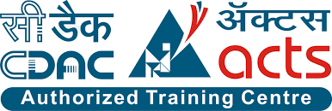

Chennai

**SUBMITTED BY**

|  |  |
| --- | --- |
| **PRN No.** | **Name** |
| 230360820060 | Vishal Waje |
| 230360820012 | Dipali Waghmare |

**UNDER THE GUIDENCE OF:**

**Mr. Sakthi Saravanakumar Sir**

and Faculty Member

ACTS, Chennai

**Abstract: -** In present scenario, people are buried up in a heavy work culture, as everyone is engaged with busy schedules, and hectic tasks which make them deviate from family life. If any issues encounter unexpectedly, it distracts them and makes them choose over the work they have to accomplish primarily. It is important to manage both professional and family life. In such circumstances, every one of us would have fantasized about a kind of house which doesn’t have any leaks in pipes, if it doesn’t have any mess in fixing a furniture and a kind of house which never face any maintenance issues and every one of us have thought that a life would be much better if no point of issue arises in getting a service at your door step and if there is no mess in bargaining a labour for home service. In such situation’s E-Commerce plays a vital role in today’s life as it has so many advantages in our life because it makes convenient in daily life of the people. So, giving a thought to that aspect of life is to design and develop a system that provides many services at your doorstep in just one click. A System that provides variety of services like plumbers, movers and packers, repair persons, cleaners, electricians, painters, taxi service laundry and many more. To make it comfortable for all the users our system also provides a mobile environment which offers ease in accessing our services. A very simple process is carried out to book a service(s), and our system is specialized with providing a confirmation email about the selected service. People can choose the particularity of service required by uploading the image of desired specification. System is versatile as service can be booked from everywhere to anywhere you desire.

**Introduction of Project:**

HomeEase is a platform to make our urban lives more fulfilling to solve our needs in ease. Hence the name, HomeEase.

The platform helps customers hire trusted professionals for services such as electrician, cleaning, plumbing, carpentry, interior design, home/office renovation and more. It enables users to find any service professional, they want to be the go-to platform helping customers complete the projects that are important to their urban lives everything from designing their homes to any maintenance activity.

**Objective and Scope of Project:**

Optimizing and simplifying User experience: Booking seems a simple two-step process, but a lot happens in the back-end. They majorly utilize data available on the total no. of professionals in the area, predicting their availability and accordingly making the schedule of the service. They also take into account the work pattern of the service provider.

Maintaining professionalism and security: HomeEase monitors and captures various disciplinary aspects of the providers in form credentials of his gov. approved ID, punctuality, work order details etc. The user and provider both can check their work allotments or status which will provide clear idea.

**Implementation Technologies:**

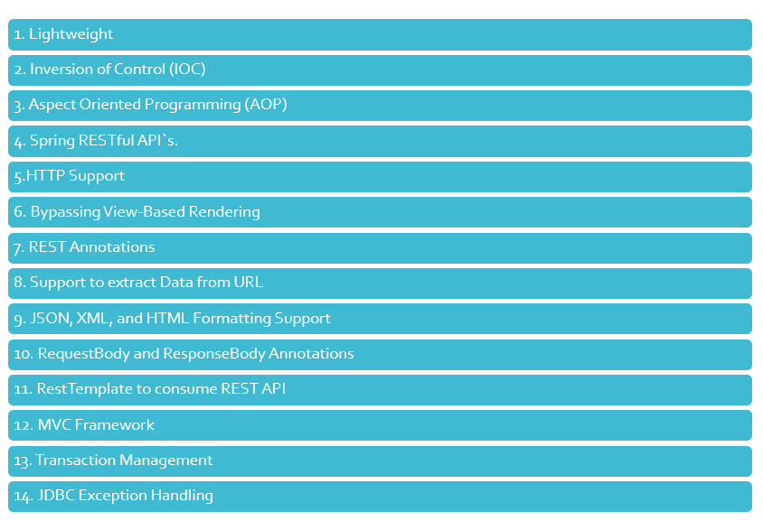**1)Spring REST API:**

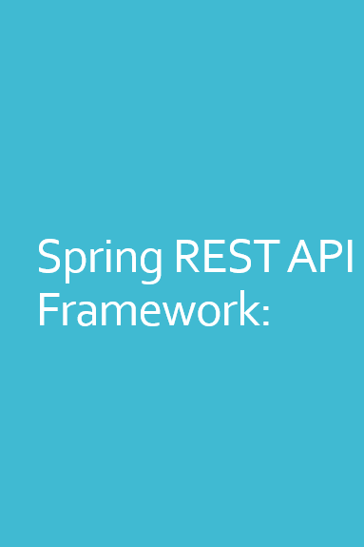

1. Lightweight

Spring is modular lightweight framework which allows you to selectively use any of its modules on the top of Spring Core.

2. Inversion of Control (IOC)

This is another top feature of Spring framework where application dependencies are satisfied by the framework itself. Framework creates the object in runtime and satisfies application dependencies.

3. Aspect Oriented Programming (AOP)

Aspect Oriented Programming (AOP) is very popular in programming world and in Spring it is well implemented. Developer can use Aspect Oriented Programming (AOP feature of Spring to develop application in which business logic is separated from system services.

4. Container

Spring provides their own container for managing the bean lifecycle.

5. HTTP Support

In Spring MVC, a controller can handle the requests for all HTTP methods, which is a backbone of RESTful web services. You can handle a GET, POST, PUT and DELETE methods to remove resources from the server.

6. Bypassing View-Based Rendering

By using this, you can directly send a response to a client, as the resource clients want and also in the format they want.

7. REST Annotations

The Spring 4.0 release added a dedicated annotation, @RestController, to make the development of RESTful web services even easier.

8. Support to extract Data from URL

@RequestParam to get the value of those query parameters but, not to worry, Spring MVC also provides a @PathVariableannotation, which can extract data from a URL.

9. JSON, XML, and HTML Formatting Support

Another key aspect of RESTful web services is Representation, meaning the same resource can be represented in different formats, like JSON, XML, HTML, etc.

10. RequestBody and ResponseBody Annotations

Spring MVC also provides @RequestBody annotation, which uses HttpMethodConverter implementations to convert inbound HTTP data into Java objects passed into a controller's handler method.

11. RestTemplate to consume REST API

The Spring framework also provides a template class, RestTemplate which is similar to JdbcTemplate, and, JmsTemplate, can consume REST resources. You can use this class to test your RESTful web service or develop REST clients.

12. MVC Framework

Spring MVC Framework is used for developing MVC based web applications.

13. Transaction Management

Spring framework provides generic Transaction Management layer which can be used with or without J2EE(JEE) environment.

14. JDBC Exception Handling

Spring provides their own abstraction of JDBC exception which further simplifies the exception handling in program.

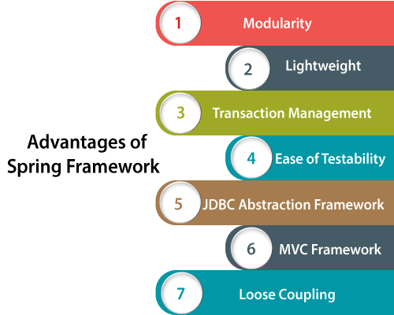**Advantages of Spring Framework:**

**Introduction to Microservices in Spring Framework:**

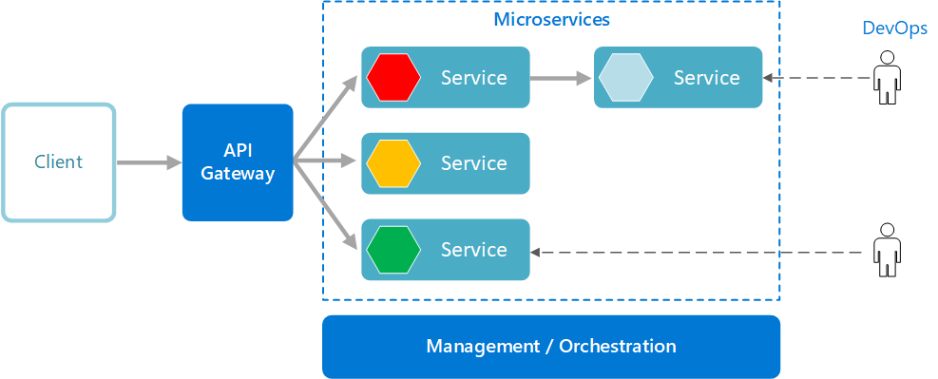

**Microservices architecture,** often called microservices, is an architectural approach or style of application development. It involves dividing large applications into smaller, functional units capable of functioning and communicating independently.

Developers have long waited for an alternative to monoliths to achieve the scalability, simplicity and flexibility needed to create highly sophisticated software applications.

Monolithic architecture is like a large container holding all software components of an application: user interface, business layer, and data interface. This had several limitations, including inflexibility, lack of reliability, difficulty scaling, slow development, etc. It was to bypass these issues that microservices architecture was created.

Monolithic Architecture Vs. Microservices Architecture

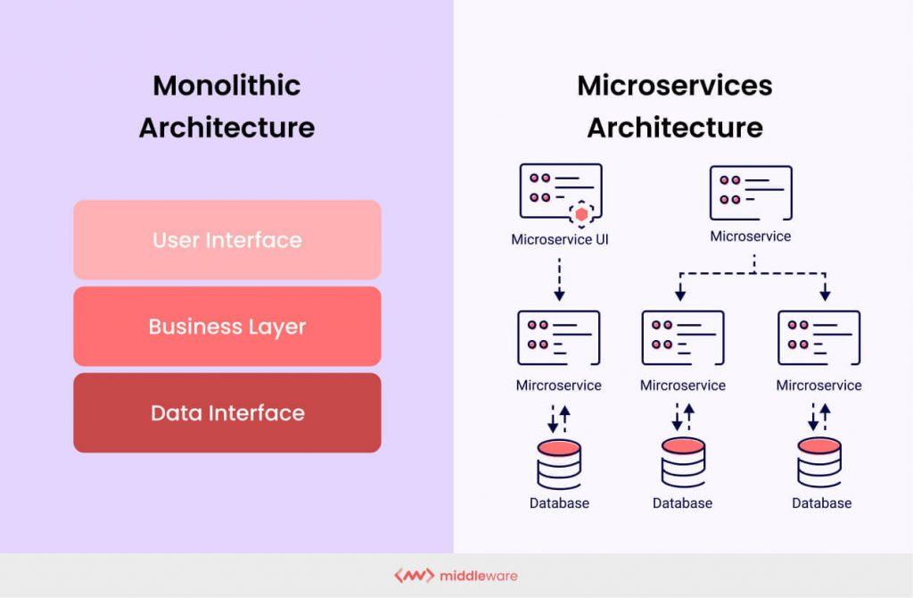

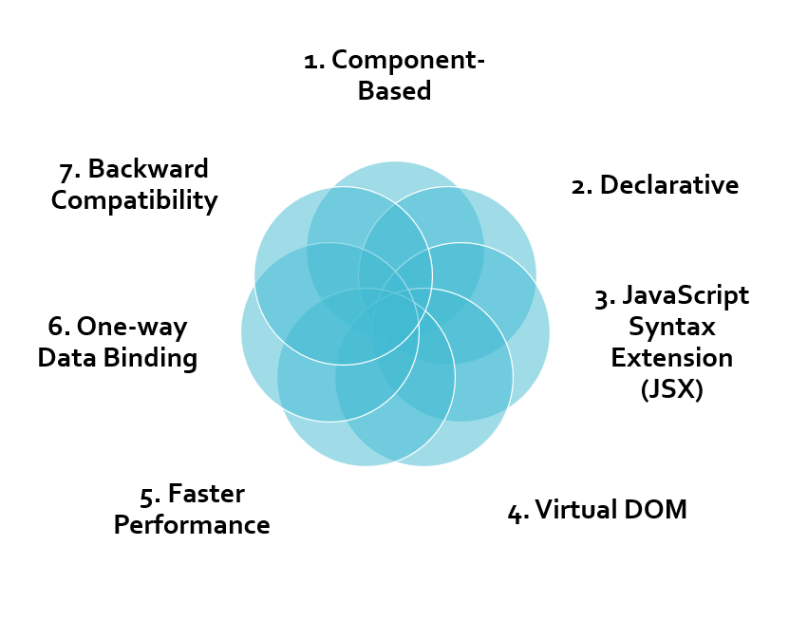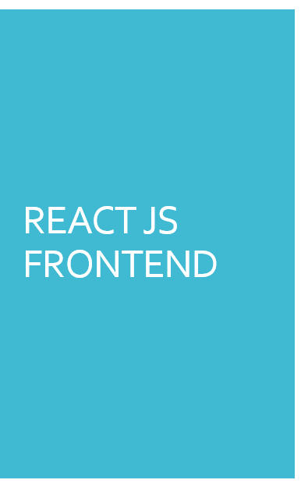**REACT JS:**

**React** can be used with a combination of several JS libraries and frameworks like jQuery, Backbone, or even Angular in MVC. The core functionality of React is developed in a way that it makes front end development fast, modular, simple, and scalable.

1. Component-Based: A single React app consists of several components. This modular, component-based approach in React JS enables it to integrate and display the design schemes.

React apps generally have two kinds of components – Stateless Functional Components and Stateful Class Components.

2. Declarative: React provides a great developer experience to its users, which in turn gives a good UX. The developers are able to build web apps faster and can more easily debug the screen or components when using React.

3. JavaScript Syntax Extension (JSX): JSX is used to develop robust user interfaces. Developers can write the HTML structures and JS codes in the same file, which makes understanding and debugging codes an easy feat since using the complex JS DOM structure can be avoided.

4. Virtual DOM: React has provisions of a Virtual DOM (VDOM) which enables easy manipulation. In the event when the state of an object is changed, the VDOM changes that individual object in the real DOM and not all the other existing objects.

5. Faster Performance: The VDOM enables the React JS-based web apps to run faster. Plus, React as a platform can be quickly download configuration process.

6. One-way Data Binding: Reacts unidirectional data flow enables a developer to nest baby components with the parent components. Because of this, a developer has better control over the web app since he knows the source of errors.

7. Backward Compatibility: The reason why most developers prefer using React for front end development is this functionality because it enables them to work on the software with older versions of libraries.

8. Easy Debugging: React JS has a large developer community that enables easy debugging of web apps. There’s even a small browser extension that can add the React tab in the developer tools option on Chrome. This makes inspecting the React components easier.

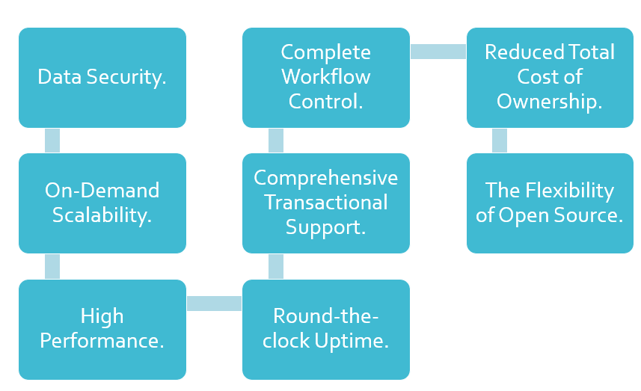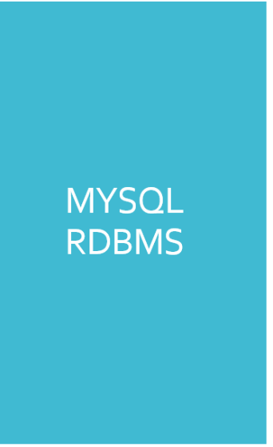**MYSQL RDBMS:**

**Project Plan:**

MySQL is a free-to-use, open-source database that facilitates effective management of databases by connecting them to the software. It is a stable, reliable and powerful solution with advanced features like the following:

1. Data Security

MySQL is globally renowned for being the most secure and reliable database management system. The data security and support for transactional processing that accompany the recent version of MySQL, can greatly benefit any business especially if it is an eCommerce business that involves frequent money transfers.

2. On-Demand Scalability

MySQL offers unmatched scalability to facilitate the management of deeply embedded apps using a smaller footprint even in massive warehouses that stack terabytes of data. On-demand flexibility is the star feature of MySQL.

3. High Performance

MySQL features a distinct storage-engine framework that facilitates system administrators to configure the MySQL database server for a flawless performance.

4. Round-The-Clock Uptime

MySQL comes with the assurance of 24X7 uptime and offers a wide range of high availability solutions like specialized cluster servers and master/slave replication configurations.

5. Comprehensive Transactional Support

MySQL tops the list of robust transactional database engines available on the market. With features like complete atomic, consistent, isolated, durable transaction support, multi-version transaction support, and unrestricted row-level locking, it is the go-to solution for full data integrity.

6. Complete Workflow Control

With the average download and installation time being less than 30 minutes, MySQL means usability from day one. Whether your platform is Linux, Microsoft, Macintosh or UNIX, MySQL is a comprehensive solution with self-management features that automate everything from space expansion and configuration to data design and database administration.

7. Reduced Total Cost of Ownership

By migrating current database apps to MySQL, enterprises are enjoying significant cost savings on new projects. The dependability and ease of management that accompany MySQL save your troubleshooting time.

8. The Flexibility of Open Source

All the fears and worries that arise in an open-source solution can be brought to an end with My SQL’s round-the-clock support and enterprise indemnification. The secure processing and trusted software of MySQL combine to provide effective transactions for large volume projects. It makes maintenance, debugging and upgrades fast and easy while enhancing the end-user experience.

**Hardware and Software Requirements (Minimum):**

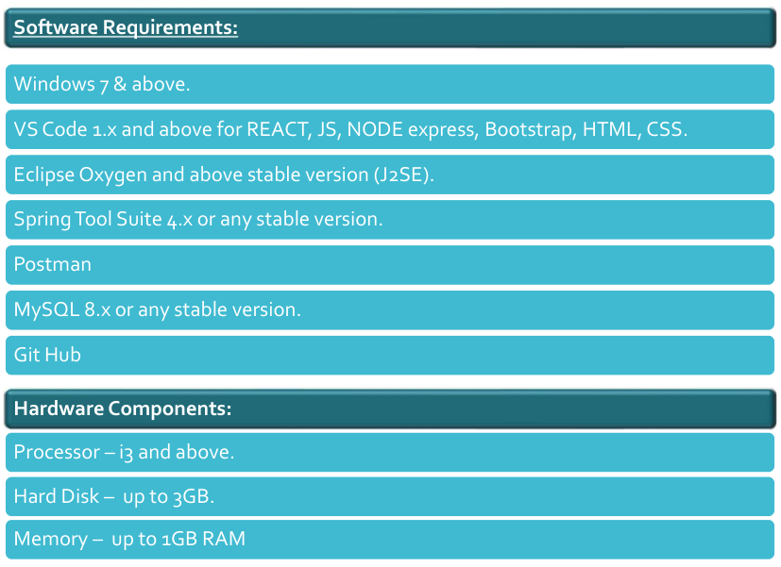



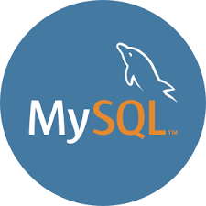

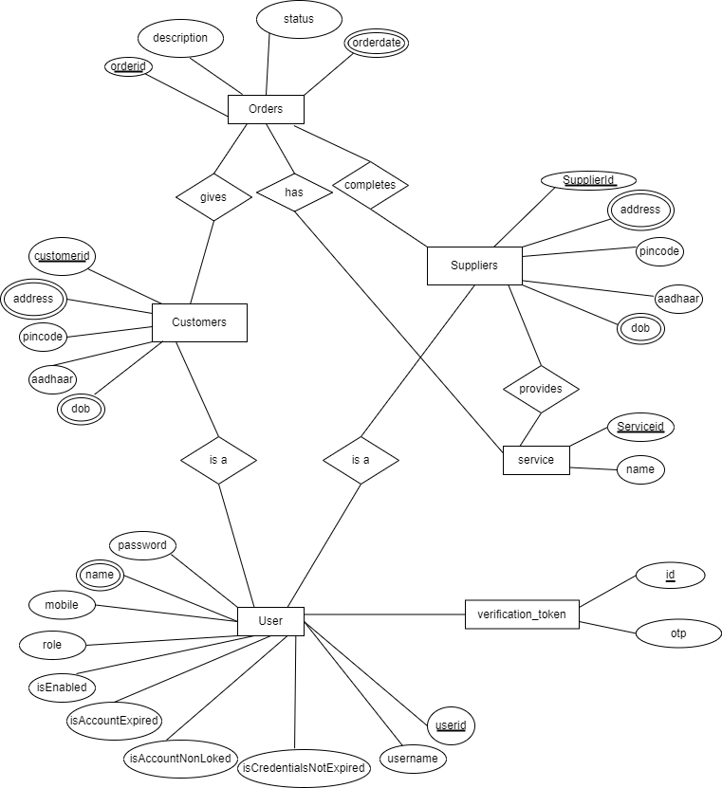**ER Diagram:**

**Table Structures:**

**Customer Table:**

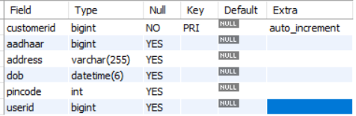

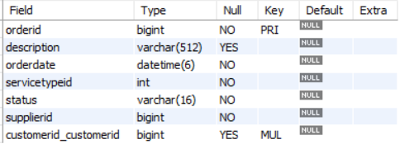**Orders Table:**

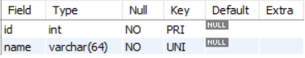**Services Table:**

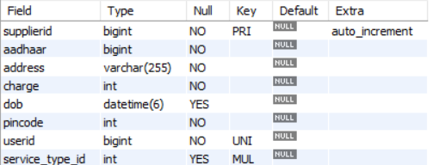

**Suppliers Table:**

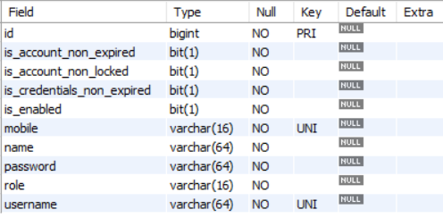

**Users Table:**

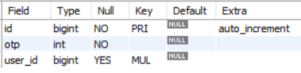**Verification Table:**

**UML Diagrams:**

1. 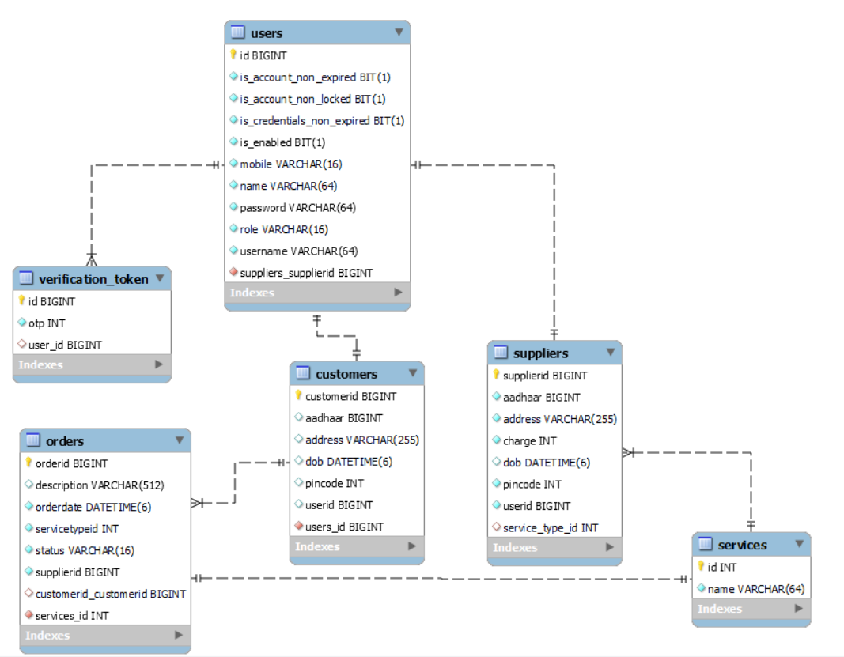**Class Component Diagram:**
2. **Process Flow Diagram:**

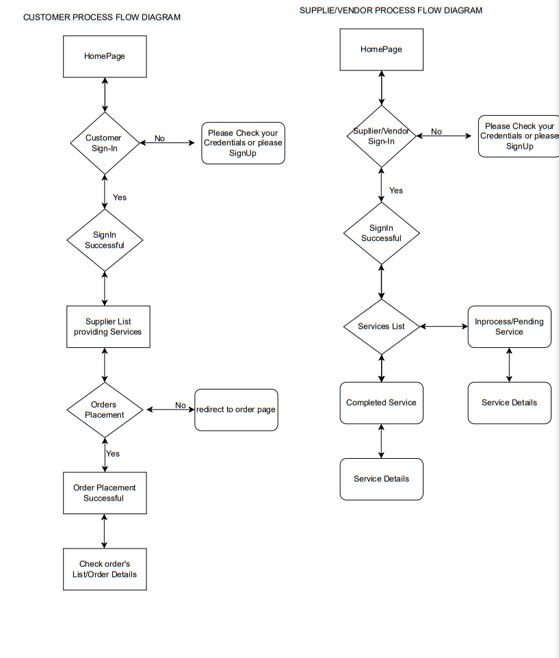

Admin Process Flow Diagram

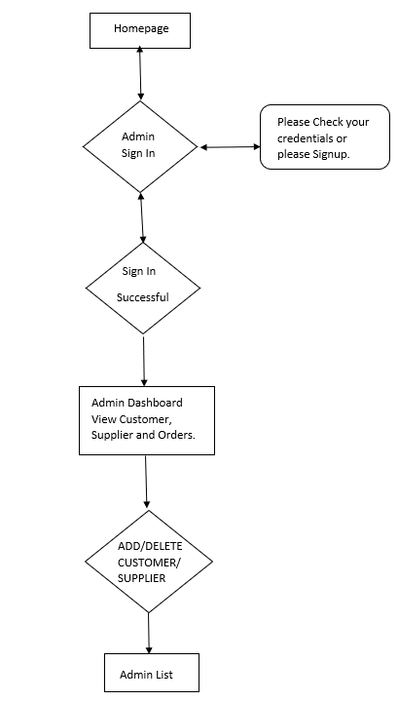

No

yes

1. **Use case Diagram**

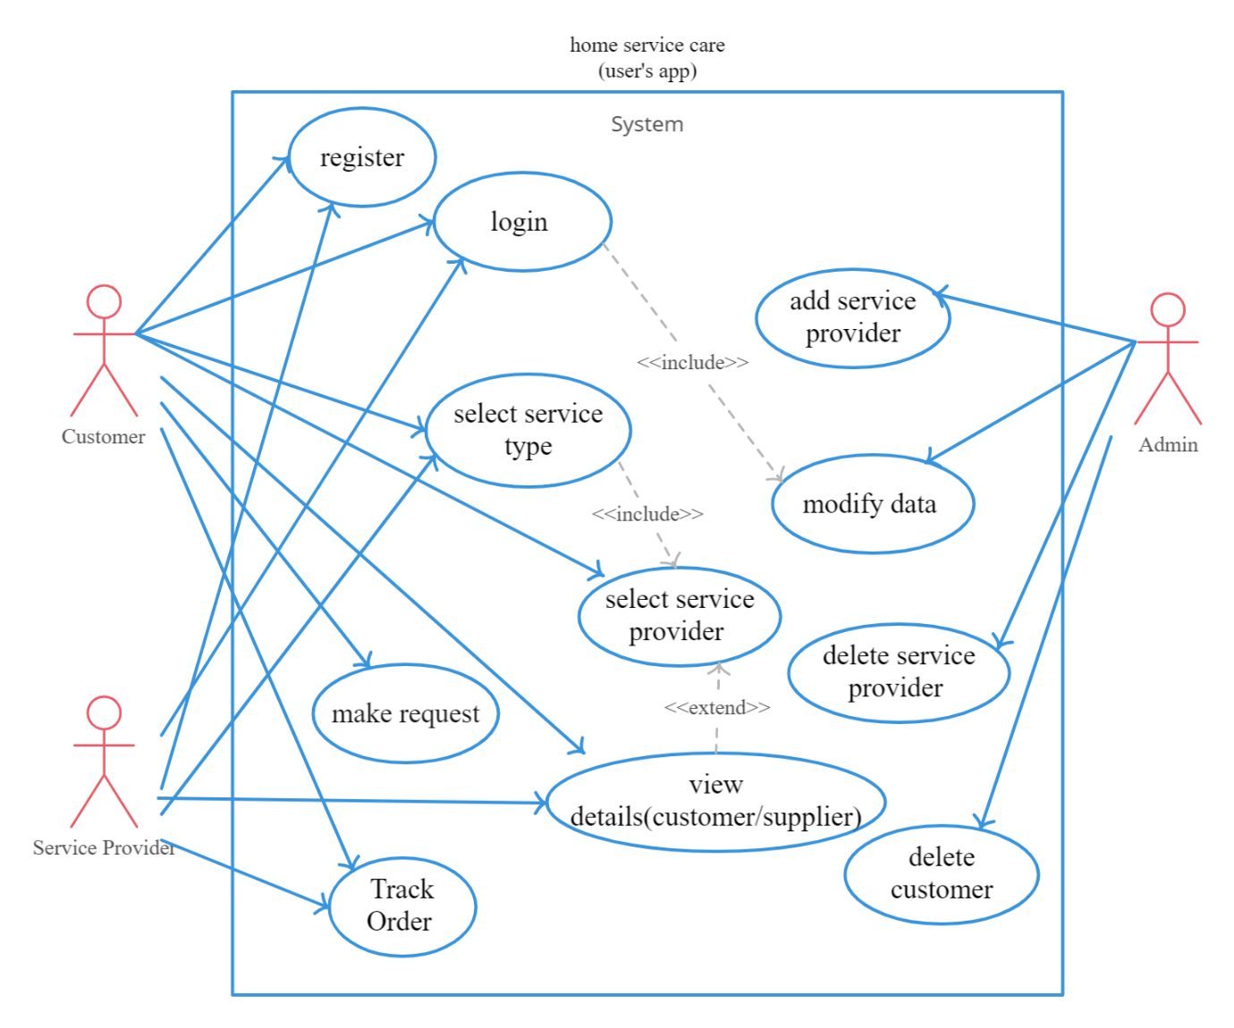

1. **Dataflow Diagram**

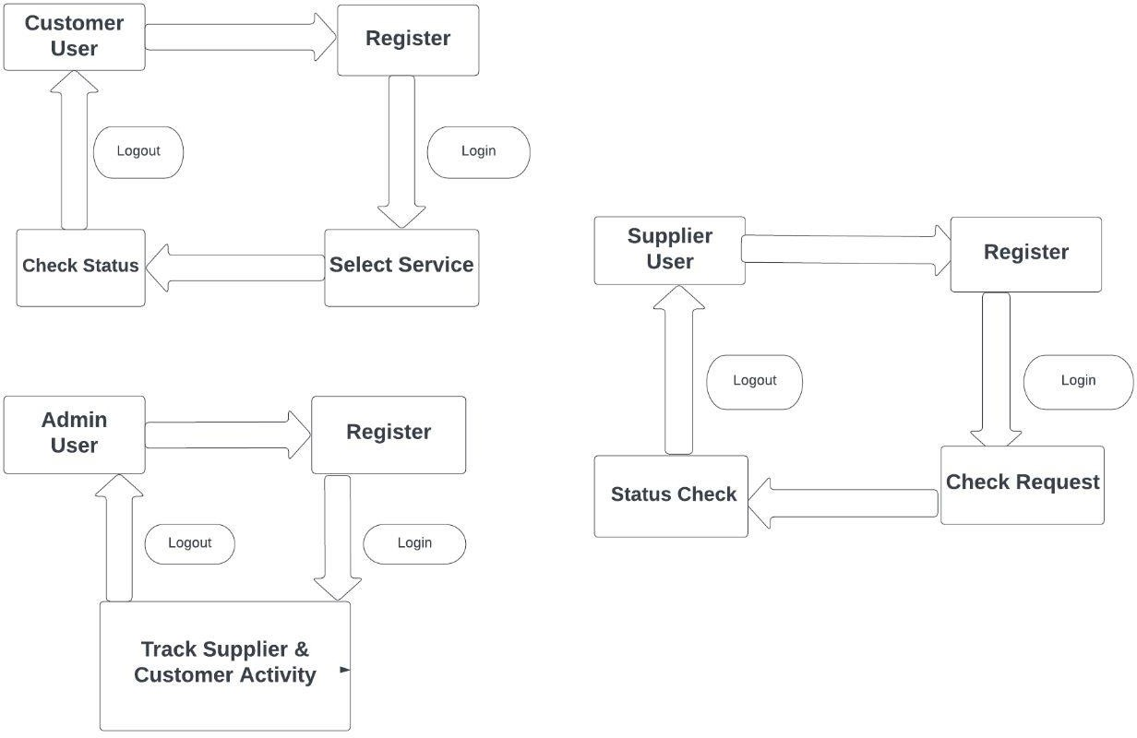

1. **Dataflow Diagram**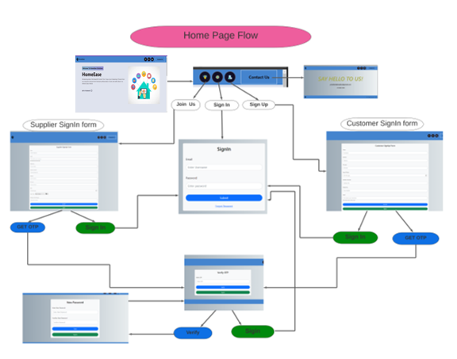

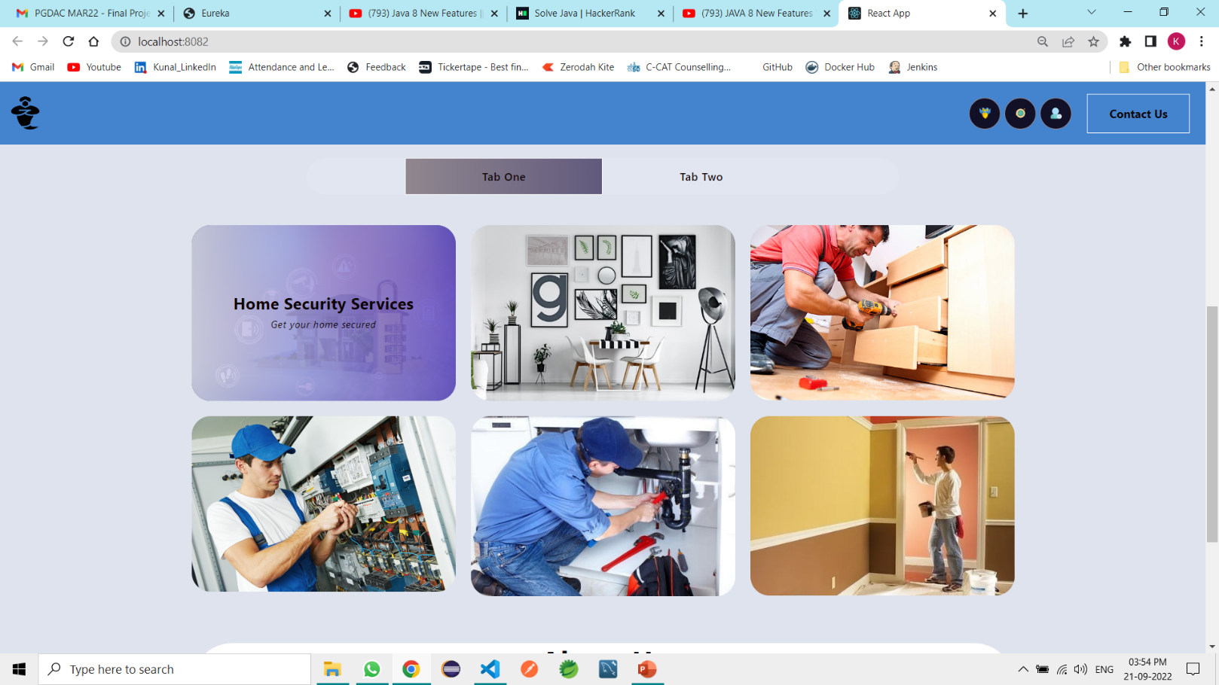

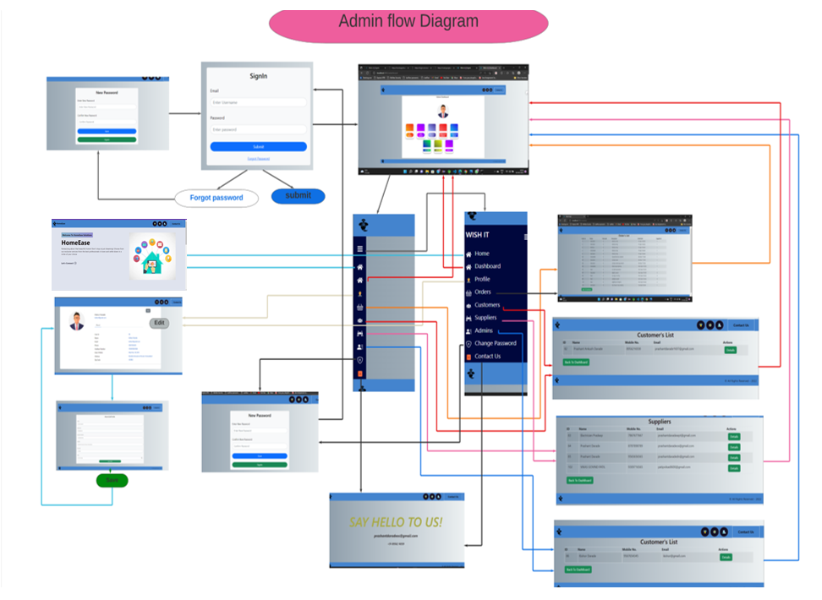

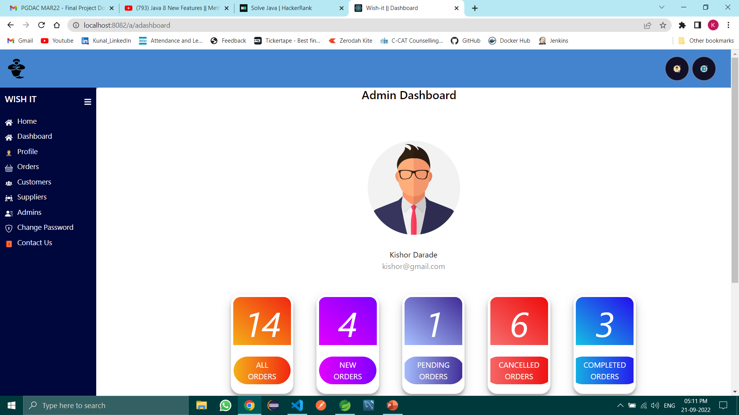

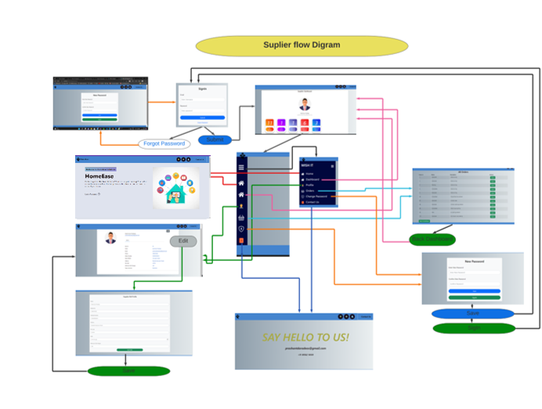

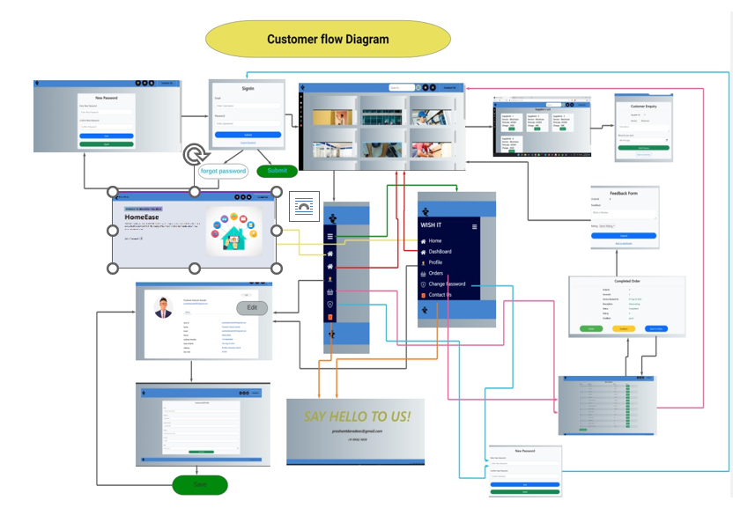

**End to End Flow of Application:**

**Customer User:**

i. Customer will login to the portal or will have to register if he is not a registered user. Customer has to provide pin code compulsory for exact viewing of suppliers in nearby locality. Authentication will be done by Email OTP verification.

ii. After registration customer will login and Dashboard page will be displayed to him which will display the profile and order status if any. Customer can select the service he wants to avail from dashboard page or can go to home page.

iii. From home page customer can click on any service and then the service providers in his locality will be displayed sorted as pin code.

iv. After selecting the service provider a description form will appear which needs to filled by the customer in brief for issues he is facing.

v. After submitting the description form the details of customer and his issue will go to the concerned supplier.

vi. Customer will be able to track his request if it’s been ‘Accepted’, ‘Declined ’or ‘Pending’ by the respective supplier of the category chosen.

vii. Customer can further contact with customer for detailed information regarding the described issue.

**Supplier User:**

i. Supplier will login to the portal or will have to register if he is not a registered user. Supplier has to select his category of work and the location pin code compulsory. Authentication will be done by Email OTP verification.

ii. After registration supplier will login and dashboard page will be displayed to him which will display the profile and order status if any. Supplier can view the request from customers.

iii. From dashboard page supplier has to either ‘Accepted’ or ‘Declined’ the request made by the respective customer.

iv. Once the request is Accepted the details of customer will be visible to the supplier along with the description of his issues.

v. Supplier can further contact with customer for detailed information regarding the described issue.

**Admin:**

i. Admin will login as Admin from the login page and will be able to see tabs of total customers, total suppliers, orders and can manage all of them.

ii. Admin is the Project manager and responsible add user, edit user, add service provider, validate service provider. Admin has responsibility to make good co-ordination between customer and service provider.

**Future Scope:**

We will meet our standards in an iterative way, and able to train thousands of our partners. We will build the largest training upskilling programme, and, aim to transform our partners into micro-entrepreneurs with our fintech and lending products. The idea for HOMEEASE emerged with the Gov. Of India initiative VOCAL FOR LOCAL and we are promised for the sustainable development towards it.

**References:**

Mr. Sakthi Saravanakumar Sir to co-ordinate and support during project.

Mrs. Sumithra Ma'am, for guiding us throughout the Course.

International Journal of Engineering Research & Technology (IJERT) An Online System for Household Services. Special Issue – 2018.

Website & YouTube Channels: Durga Software Solutions, Stackoverflow, Geeksforgeeks, Javatpoint, W3schools, Daily code buffer, Java Techie, Edureka, Gatesmashers, Java brains, Learn code with Durgesh, Naresh i technologies, Neso Academy, Sanjeev Thiyagarajan, Smart programming, TechEFX, WsCube Tech, Krish Dinesh.

Special thanks to ACTS Chennai Pvt Ltd. for providing us the knowledge and giving us capability to deal with new technologies during the project.

**THANK YOU!**

